*Gourav Khadge and Leif Park Jordan*

Results and Background Analysis: Expanded Predator-Prey Model GUI

The *Volterra-Lotka* predator prey model is the standard model of ecosystem dynamics that assumes:  
1. logarithmic population growth rate   
2. linear predator growth and prey decline proportional due to predation to the opposing population

The model expansion adds two additional terms:

3. Disease and overcrowding in prey (represented by parameter μ)

4. First order time delay for predator growth (represented by parameter σ)

The terms we add to the *Volterra-Lotka* predator prey model are bolded below:

https://lh5.googleusercontent.com/BTjF9xobSynbbOYiG9Z8bG7eFLjWyPumo-rbX7hJbQtfFIHNUBOD0k1YNDOS_FNkeHzFLxXWHf9wh5iTdUyCfGQMfBl_W9wKxGc9SW65rgXSX-5ebeH7bNmtXBkV_367uw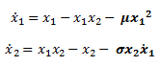

Stable Points  
The stable points of this system can be found by finding such that .

Simplifying these two equations, we find:

For to be 0, either or

For to be 0, either or

From these we see that the following points will satisfy these criteria and will thus be fixed points of the system:

The first fixed point represents the trivial solution in which there are no existing predators or prey.

The second fixed point represents a stable prey population in the absence of predators bounded by the rate of disease and overcrowding.

The third fixed point represents coexisting populations of predator and prey.

The third fixed point becomes invalid for telling us that no stable predator population can exist if death due to disease and overcrowding in prey is too high.

We see a transcritical bifurcation at at which point the second and third fixed points overlap, marking the boundary between stable and unstable populations of predator.

Regions of Behavior

There are four distinct regions of behavior of the system in the parameter space spanning the domain 0<σ<2 and 0<μ<2. These regions are

1. Limit Cycle,

2. Stable Focus

3. Stable Node (with predators)

4. Stable Node (no predators).

These are shown in Figure 1.

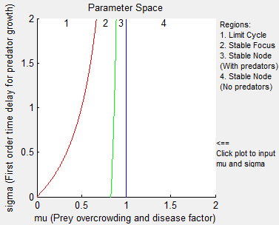

*Figure 1: Regions of behavior of the system in the parameter space.*

The Jacobian of the predator-prey system is

First, note that the [0,0] fixed point is always a saddle point (and thus unstable): the Jacobian of the system near it is

which has eigenvalues 1 and -1, regardless of μ or σ. This makes the fixed point a saddle point.

The stability and behavior of the other two points changes as a function of μ and σ. First, a Hopf Bifurcation occurs when the [1, 1-μ] fixed point is at the boundary between a stable focus and an unstable focus with a limit cycle. This occurs when the trace of the Jacobian near that fixed point equals zero:

Therefore, a Hopf bifurcation occurs when , or, in other words, when , marking the boundary between regions 1 and 2. For values of μ below this value, every fixed point is unstable and the system exhibits a limit cycle.

In addition, a transcritical bifurcation marking the boundary between regions 3 and 4 occurs when the [1, 1-μ] and the [1/μ, 0] fixed points exchange stabilities. The two fixed points coincide when μ = 1, which suggests a transcritical bifurcation. Indeed, at this point, the Jacobian is

One of the eigenvalues of this matrix is 0, so we see that a transcritical bifurcation does, in fact, occur at this point. The [1, 1-μ] fixed point exchanges stability with the [1/μ, 0] fixed point. At this point, the steady state predator population which for 0<μ<1, decreases from its value of 1- μ to 0, and stays at 0 for μ1, marking the transition from region 3 to region 4.

For values between the two bifurcations, the stable node is [1, 1-μ]. The Jacobian of the system near this point is

The determinant of this matrix is

When the determinant is positive, the system will exhibit stable node behavior. When it is negative, the system will exhibit stable focus behavior. The determinant switches sign when

Solving for μ, we find the following equation which marks the boundary between regions 2 and 3.

For values of μ larger than this value, the fixed point will be a stable node. For values below this value, the fixed point will be a stable focus.

In summary, then, for values of μ less than (the Hopf Bifurcation), the system is entirely unstable and exhibits a limit cycle. For values of μ greater than 1, the [1/μ, 0] fixed point is a stable node and the other two fixed points are unstable. For values of Μ between the the Hopf Bifurcation and 1, the [1, 1-μ] fixed point is stable. It is a stable focus for , and a stable node for . These behaviors are reflected in Figure 1.

Effects of μ on the System

The effect of μ on the system is illustrated by varying μ for constant σ as shown in Figure 2.

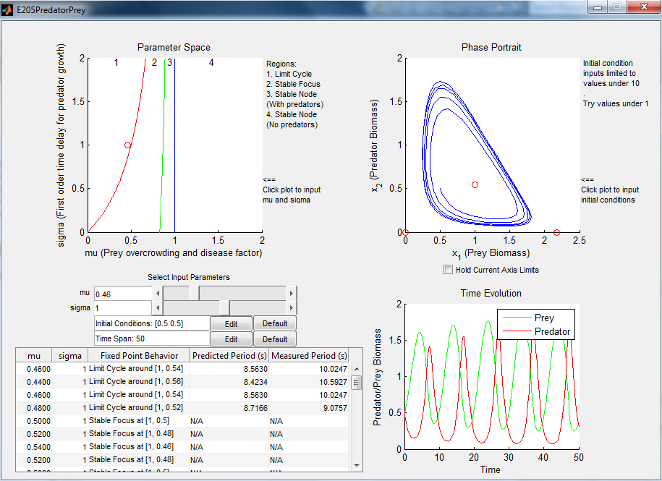 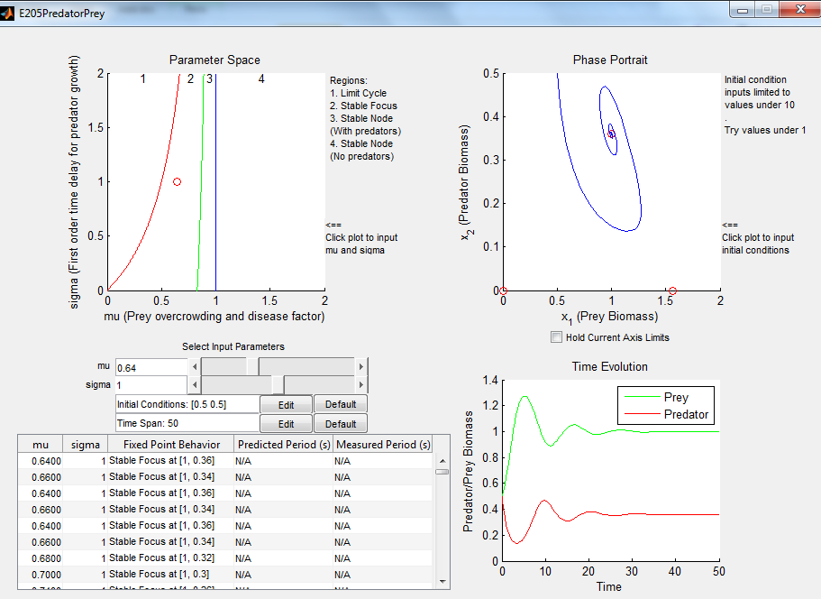

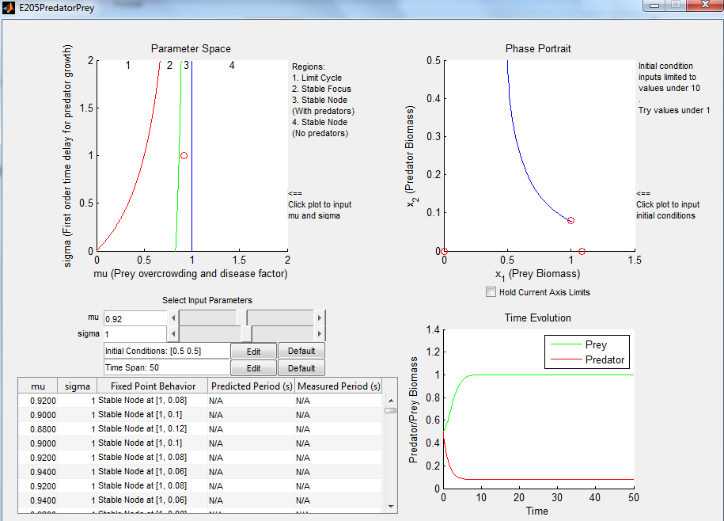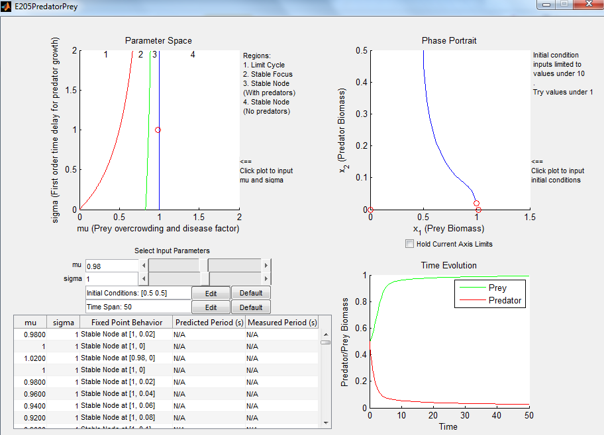

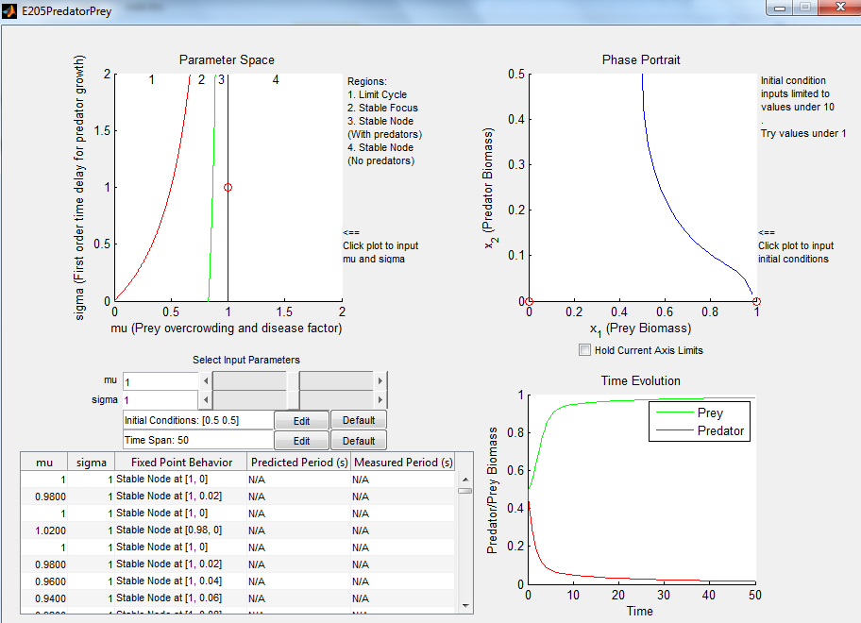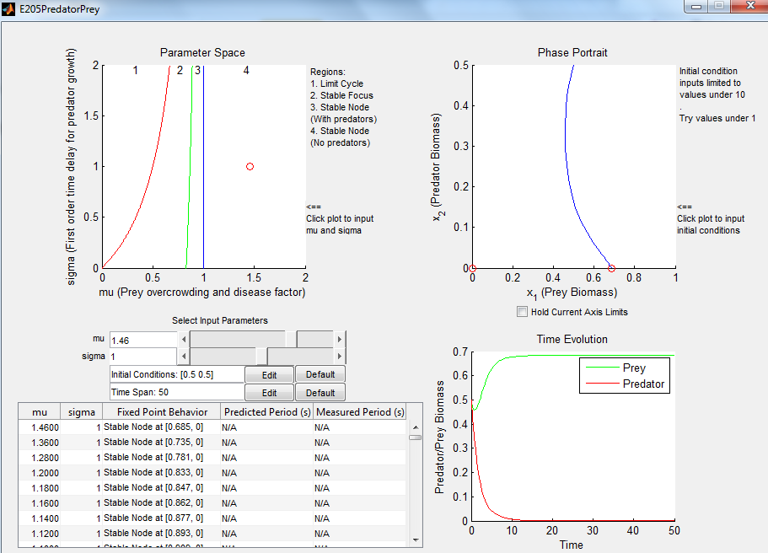

*Figure 2a-f: Increasing μ for constant σ = 1.*

*a) (top left) μ = 0.46, unstable limit cycle*

*b) (top right) μ = 0.64, stable focus*

*c) (middle left) μ = 0.92, stable node, stable predator population*

*d) (middle right) μ = 0.98, stable node, stable predator population, approaching transcritical bifurcation*

*e) (bottom left) μ = 1, stable node, transcritical bifurcation, no stable predator population*

*f) (bottom right) μ = 1.46, stable node, no stable predator population*

μ has the direct result of adding destructive terms to the population of the prey. This has the result of decreasing the population of the predator since more prey is lost to disease and overcrowding rather than to predation. This can be seen in the decreasing value of population in the stable fixed point for the range 0<μ<1 given by [1, 1- μ]. At μ = 1, the transcritical bifurcation can be observed at which point, the population losses due to disease and overcrowding term become large enough that there is not enough prey to sustain a stable predator population. For increasing μ>1, the stable fixed point becomes [1/μ, 0] with a no predators in the steady state and a stable prey population dictated by μ.

Effects of σ on the System

The effect of σ on the system is illustrated by varying σ for constant μ as shown in Figure 3.

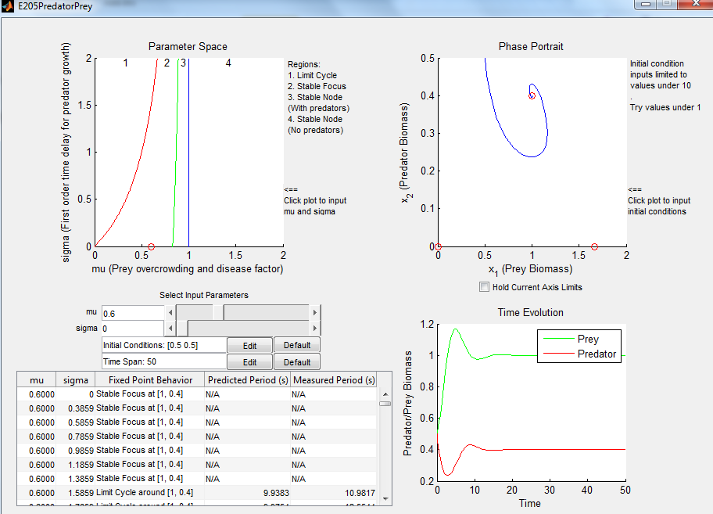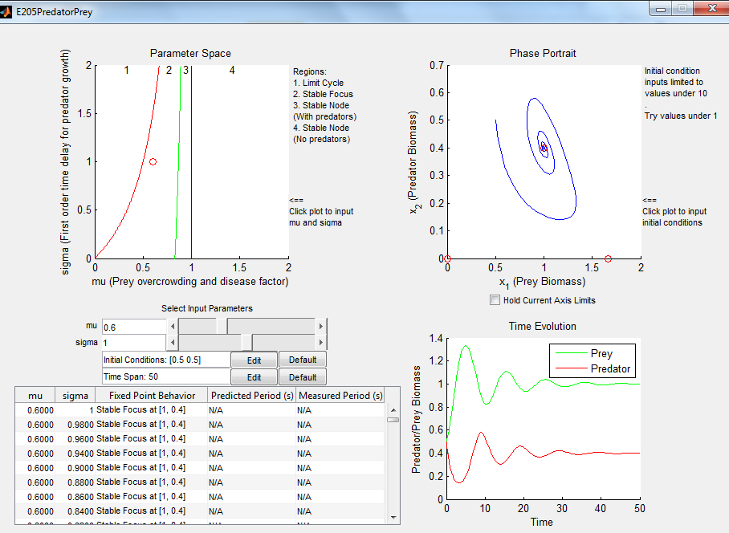

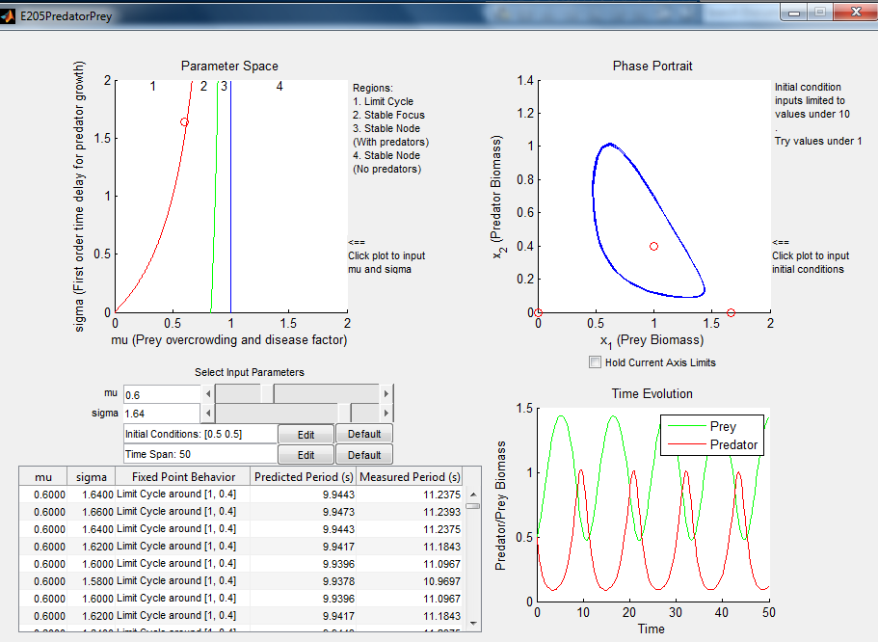 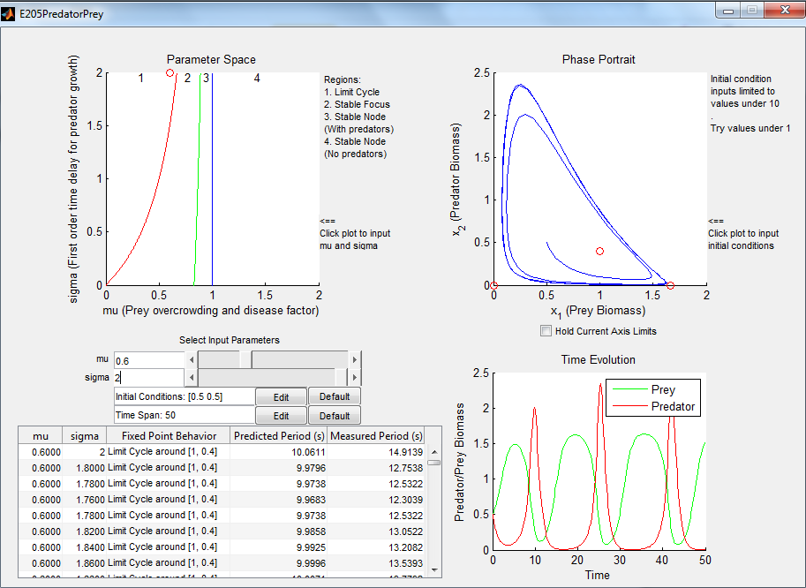

*Figure 3a-d: Increasing σ for constant μ = 0.6.*

*a) (top left) σ = 0, stable focus*

*b) (top right) σ = 1, stable focus with increased oscillation*

*c) (bottom left) σ = 1.64, limit cycle*

*d) (bottom right) σ = 2, limit cycle with increased magnitude of oscillation*

σ has the direct result of delaying the response of the predator population to changes in the prey population. This has the effect of inducing oscillations in an otherwise nonoscillatory system, or as shown in Figure 2, increasing the magnitude of oscillation in such a system. If σ grows too large, the oscillations become increasingly out of phase and instability occurs as a Hopf bifurcation is induced. This induces a limit cycle for large enough σ. The magnitude of oscillation in the limit cycle is increased with further increasing σ.